**Availability Set**

**Introduction**

Availability Sets in Azure provide high availability and resiliency for virtual machines (VMs) by distributing them across fault domains and update domains. This documentation explains the key concepts, usage, and best practices related to Availability Sets.

**Key Concepts**

**Fault Domains**

A fault domain is a group of hardware and infrastructure components within an Azure data center that share a common power source and network switch. Fault domains are isolated from each other to minimize the impact of failures. By distributing VMs across different fault domains, you ensure that if one fault domain experiences an issue, the VMs in other fault domains remain operational.

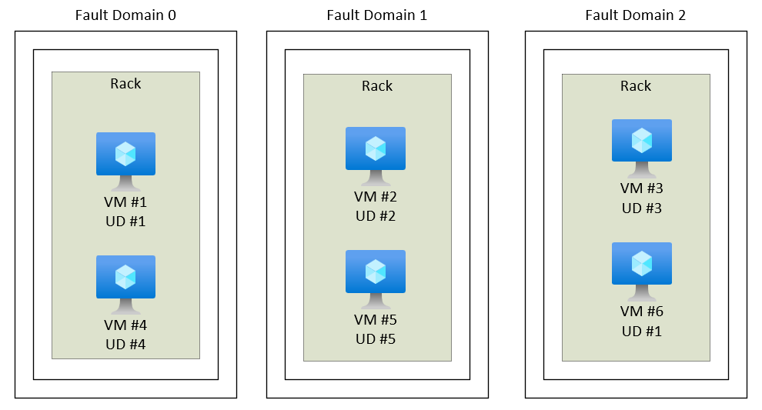

**Update Domains**

An update domain is a logical group of VMs within an Availability Set that can undergo maintenance operations together. Azure uses update domains to minimize the impact of planned maintenance activities. During maintenance, Azure reboots the VMs in one update domain at a time, allowing the other update domains to continue running. By separating VMs into different update domains, you reduce the risk of downtime during maintenance operations.

**High Availability**

Availability Sets ensure high availability for your applications. By distributing VMs across fault domains within an Availability Set, Azure guarantees that if a fault domain experiences a hardware or software failure, the VMs in other fault domains will continue to operate. This distribution of VMs across fault domains provides resiliency and minimizes the risk of complete service disruption.

**Planned Maintenance**

Azure uses update domains to perform planned maintenance tasks such as applying patches or updates to the underlying infrastructure. By distributing your VMs across different update domains, Azure can perform maintenance on one update domain at a time, while keeping the VMs in other update domains running. This helps maintain service continuity and reduces the impact of maintenance on your applications.

**Creating an Availability Set**

To create an Availability Set in Azure, follow these steps:

1. Log in to the Azure portal.

2. Navigate to the desired resource group where you want to create the Availability Set.

3. Click on the "Add" button to create a new resource.

4. In the search bar, type "Availability Set" and select it from the suggestions.

5. Provide a unique name for the Availability Set.

6. Configure the number of fault domains and update domains based on your application's requirements. Azure recommends having at least two fault domains and two update domains for optimal availability.

7. Choose the appropriate region where you want the Availability Set to be created.

8. Complete the creation process by providing any additional details required and confirming the creation.

Deploying VMs to an Availability Set

To deploy VMs to an Availability Set, follow these steps:

1. While creating a VM in the Azure portal, you'll reach the "Basics" tab of the VM creation wizard.

2. Under the "Availability options" section, select "Availability Set."

3. Choose the desired Availability Set from the drop-down menu. If you haven't created an Availability Set yet, you can click on the "Create new" button and follow the steps mentioned in the previous section.

4. Continue with the VM creation process by providing the necessary details, such as VM size, storage options, networking, and authentication settings.

5. Repeat the process for each VM you want to deploy within the same Availability Set.

6. Azure will distribute the VMs across different fault domains and update domains within the Availability Set, ensuring high availability and resiliency.

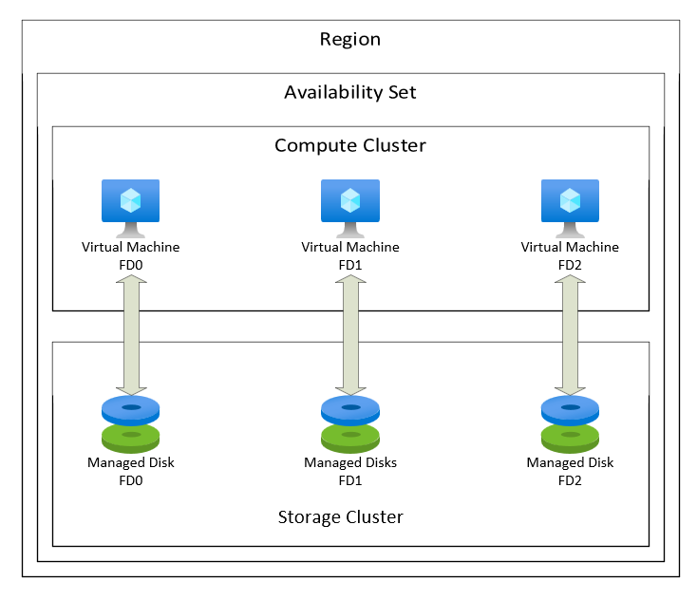

**Monitoring and Managing Availability Sets**

1. Azure Monitor: Utilize Azure Monitor or other monitoring tools to keep track of the health, performance, and availability of the VMs within the Availability Set. Set up appropriate monitoring alerts and thresholds to receive notifications about any issues or potential downtime.

2. Review and Adjust Configuration: Regularly review the fault domain and update domain configurations for your Availability Sets. Ensure they align with your application's requirements. If you need to change the fault domain or update domain configuration, you may need to recreate the Availability Set or migrate the VMs to a new Availability Set.

3. Planned Maintenance: Stay informed about planned maintenance schedules communicated by Azure. Azure performs maintenance activities during off-peak hours to minimize the impact on your applications. However, it's essential to be aware of these schedules and plan accordingly to avoid any disruptions.

**Best Practices**

**1. Deploy Multiple VMs:** It is recommended to deploy at least two VMs within an Availability Set. This ensures fault tolerance and high availability. If one VM goes down, the other VMs can continue running, reducing the risk of service disruption.

**2. Distribute Across Fault and Update Domains:** Distribute your VMs across different fault domains and update domains within an Availability Set. This distribution helps protect against hardware failures and minimizes downtime during planned maintenance. Azure automatically handles the distribution when you create VMs within an Availability Set.

**3. Consider Redundancy across Availability Zones:** For geographically redundant solutions, consider using Azure Availability Zones. Availability Zones provide even higher resiliency by distributing VMs across physically separate data centers within an Azure region. This protects your applications from region-level failures.

**4. Monitor VM Health and Performance:** Utilize Azure Monitor or other monitoring tools to monitor the health and performance of your VMs within the Availability Set. Set up appropriate alerts and metrics to promptly identify any issues and take proactive actions.

**5. Regular Testing and Validation:** Periodically test and validate the resilience of your applications within the Availability Set. Conduct failover tests to ensure that your applications can seamlessly switch to alternate VMs in case of failures. Regular testing helps ensure that your configuration is effective and your applications can withstand potential disruptions.

**Conclusion**

Availability Sets in Azure provide the foundation for achieving high availability and resiliency for your applications. By leveraging fault domains and update domains, you can protect your applications from single points of failure and minimize downtime during planned maintenance activities.

In this documentation, we covered the key concepts of Availability Sets, how to create them, deploy VMs to them, and best practices for working with Availability Sets.

By following these best practices and leveraging the capabilities of Availability Sets, you can build robust and reliable applications on the Azure platform.